**ARCHITECTURAL MODEL OF BUS STOP**

# INDEX

**LIST OF FIGURES i**

ABSTRACT ii

CHAPTER 1: INTRODUCTION 03

CHAPTER 2: LITERATURE SURVEY 05

CHAPTER 3: HARDWARE REQUIREMENTS 07

CHAPTER 4: PROJECT 16

CHAPTER 5: SOFTWARE 17

CHAPTER 6: EXPERIMENTAL RESULTS 21

CHAPTER 7: ADVANTAGES 24

CHAPTER 8: FUTURE SCOPE 25

CONCLUSION 26

REFERENCES 27

# LIST OF FIGURES

**S.NO. FIGURE NAME PAGE NO.**

|  |  |  |
| --- | --- | --- |
| **FIGURE 1.1** | **BUS STOP** | **03** |
| **FIGURE 2.1** | **ARCHITECTURAL MODEL OF BUS STOP**  **WITH AUTOMATIC SUNSHADE (1ST VERSION)** | **05** |
| **FIGURE 2.2** | **ARCHITECTURAL MODEL OF BUS STOP**  **WITH AUTOMATIC SUNSHADE (2ND VERSION)** | **06** |
| **FIGURE 3.1** | **ARDUINO UNO** | **07** |
| **FIGURE 3.2.1** | **BASIC LDR** | **08** |
| **FIGURE 3.2.2** | **LDR WITH MODULE** | **09** |
| **FIGURE 3.3** | **RAIN SENSOR WITH LM393** | **10** |
| **FIGURE 3.3** | **SERVO MOTOR** | **11** |
| **FIGURE 3.5.1** | **LED** | **13** |
| **FIGURE 3.5.2** | **LED STRUCTURE** | **14** |
| **FIGURE 4.1** | **CIRCUIT DIAGRAM** | **16** |
| **FIGURE 5.1** | **ARDUINO IDE** | **17** |
| **FIGURE 6.1.1** | **AUTOMATIC LIGHT DURING DAY** | **21** |
| **FIGURE 6.1.2** | **AUTOMATIC LIGHT DURING NIGHT** | **21** |
| **FIGURE 6.2.1** | **WHEN THE SUN IS IN WEST** | **22** |
| **FIGURE 6.2.2** | **WHEN THYE SUN IS IN EAST** | **22** |
| **FIGURE 6.3.1** | **ROOF DURING NO RAIN** | **23** |
| **FIGURE 6.3.2** | **ROOF DURING RAIN** | **23** |

# ABSTRACT

### The increasing use of transportation in mid 20th century triggered the development traffic interchanges and stations. Bus station, from their early development, were developed next to the railway stations. Increased use of buses for long intercity and international journeys were at its peak in the middle of past century. Trends in architecture and lifestyle of the time conditioned the overall design of the bus stations. Local conditions such as politics, economy and society affected the design mostly.

During the time, with lifestyle change, trends for designing the stations were evolving too. Today, bus terminal design considers more than designing a building that will serve its purpose. Spending time outside of the bus and making it comfortable is a new challenge for the designers next to making the facility serve its purpose. Following the design requirements such as design standards is not the only element that will generate good design. Civic facility such as bus terminal, bus station or interchange takes in consideration many urban factors such as providing public spaces for users and feeder area combined with it. The use of those space is very encouraged by urban designers as it is raising the quality of civic facility.

The architectural model of a bus stop with automatic sunshade is a new generation bus stop. Here the roof moves with respect to sun direction, and expands during rains. This will make the comfortable bus stop of passengers without any climatic problems. The automatic lights are installed so people can use bus stop during nights without any fear. It model satisfies the modern technology.

# CHAPTER 1 INTRODUCTION

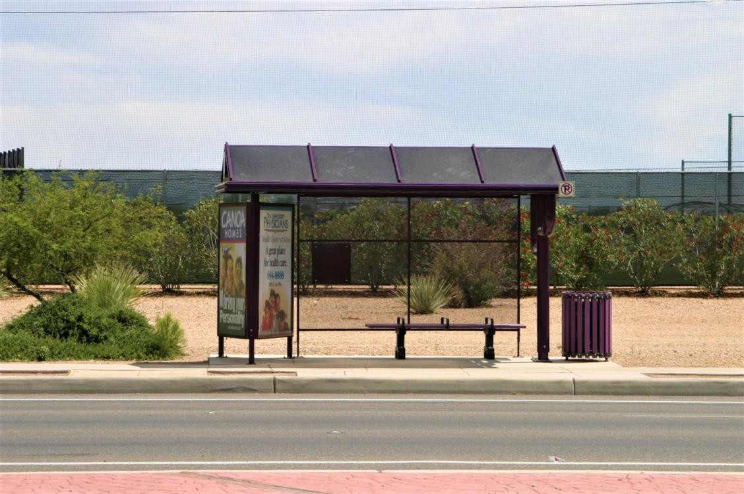

**FIGURE 1.1 BUS STOP**

A bus terminal is the point where a bus route starts or ends and in general, those are facilities which represent the door of the city and bring the first impression to visitor as a focal point at the entrance of every city. The goal is to show dependence of bus terminals' operability, considering functional attributes influenced by architectural expression and structural systems, including their impact on creating memorable and noticeable landmark.

A bus stop is a designated place where buses stop for passengers to get on and off the bus. The construction of bus stops tends to reflect the level of usage, where stops at busy locations may have shelters, seating, and possibly electronic passenger information systems; less busy stops may use a simple pole and flag to mark the location. Bus stops are, in some locations, clustered together into transport hubs allowing interchange between routes from nearby stops and with other public transport modes to maximise convenience.

They are to extend along the full length of the platform serving as a weather protection to the passengers.

* should be of high quality, prefabricated and modular.
* The Shelter roofs should be such that rain water is directed away for the vehicle side. b. Passenger Information
* Passenger information should be provided such as signage’s, route details and graphics.
* bold identification signage, transit route maps, neighbourhood maps placed at prominent locations.
* Signage and graphics should readily distinguish the bus stations from the regular stops.
* Digital display could be optionally placed at station entries. Safety and Security
* Security is essential as the BRT stops would be open for extended hours and likely to be unattended.
* Visibility is also an important criterion to security.
* Passengers should be able to see the surrounding locations and be seen from the locations outside the station.
* Adequate illumination, especially at nights is necessary. Barrier Free Design
* Accessible to by the physically challenged.
* The internal layout of the shelter should be barrier free to facilitate easy circulation.
* Access via ramps need to be provided for stops having high platforms.

# CHAPTER 2 LITERATURE SURVEY

This project is constructed by observing problems faced by the people in the bus stop due to insufficient space during rains and lack of shadow during day time and also lights during nights.

The project first designed by arduino project hub. The first model was constructed with the ldr and in that the roof only moves with respect to the sun either to right or left . the first model was so simple.

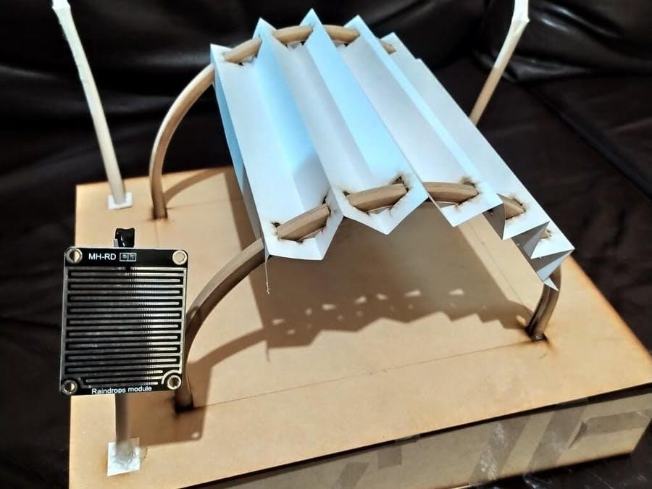

**FIGURE 2.1 ARCHITECTURAL MODEL OF BUS STOP WITH AUTOMATIC**

**SUNSHADE (1st version)**

The second model updated from the first one in which we added the rain sensor so the roof can expand during rains.

And also the automatic lights are installed in the second model.

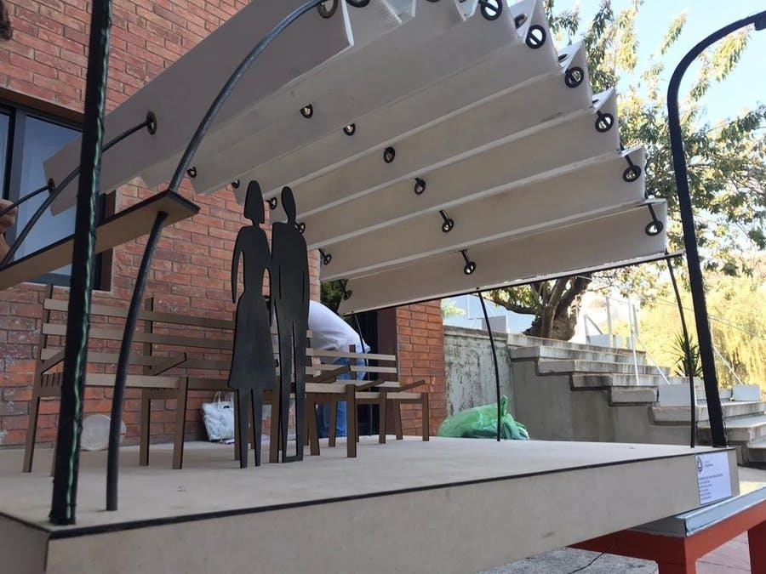

**FIGURE 2.2 ARCHITECTURAL MODEL OF A BUS STOP WITH AUTOMATIC SUNSHADE**

**(2nd version)**

# CHAPTER 3 HARDWARE REQUIREMENTS

## ARDUINO UNO:

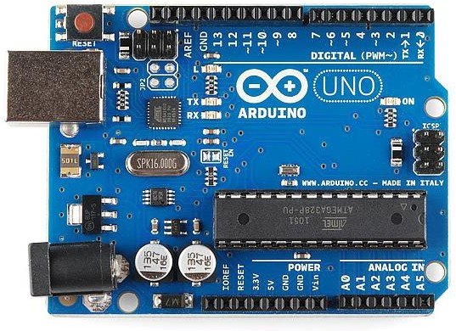

**FIGURE 3.1 ARDUINO UNO**

Arduino Uno is a microcontroller board based on the ATmega328P ([datasheet](http://www.atmel.com/Images/doc8161.pdf)). It has 14 digital input/output pins (of which 6 can be used as PWM outputs), 6 analog inputs, a 16 MHz quartz crystal, a USB connection, a power jack, an ICSP header and a reset button. It contains everything needed to support the microcontroller; simply connect it to a computer with a USB cable or power it with a AC-to-DC adapter or battery to get started.. You can tinker with your UNO without worrying too much about doing something wrong, worst case scenario you can replace the chip for a few dollars and start over again.

"Uno" means one in Italian and was chosen to mark the release of Arduino Software (IDE) 1.0. The Uno board and version 1.0 of Arduino Software (IDE) were the reference versions of Arduino, now evolved to newer releases. The Uno board is the first in a series of USB Arduino boards, and the reference model for the Arduino platform; for an extensive list of current, past or outdated boards see the Arduino index of boards.

## LDR:

A light-dependent resister is also known as LDR SENSOR, which is used to detect the intensity of light. In this blog we will discuss what LDR SENSOR is and how it can be used with the Arduino Development Board.

Have you seen the stud lights? For those who do not know, stud lights are LED that are mounted on the road and used as indicators. Remembered !! That's right, I'm only talking about those LEDs. These indicators only turn on during the night and are off during the day. But wait, how do they know, is it day or night?

Actually, when I was new in electronics, I was very keen to learn about this thing, but then when I read some articles, and I understood the real reason behind it. And the reason behind this was LDR SENSOR.

Those stud lights have LDR SENSOR, battery, controller unit and solar panel inbuilt. In the daytime, when there will be sufficient sunlight, the controller unit receives input from the LDR sensor and according to the received input the control unit either charges the battery or turns on the light.

LDR sensor module is used to detect the intensity of light. It is associated with both analog output pin and digital output pin labelled as AO and DO respectively on the board. When there is light, the resistance of LDR will become low according to the intensity of light. The greater the intensity of light, the lower the resistance of LDR .The sensor has a potentiometer knob that can be adjusted to change the sensitivity of LDR towards light.

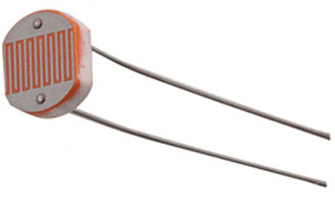

**FIGURE 3.2.1 BASIC LDR**

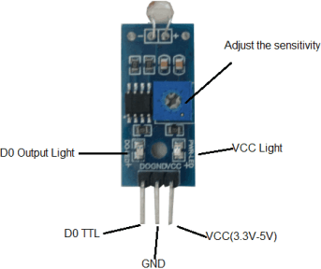

**FIGURE 3.2.2 LDR WITH MODULE**

Photosensitive resistor module most sensitive to environmental light intensity is generally used to detect the ambient brightness and light intensity.

**SAMPLE SOURCE CODE:**

void setup()

{

Serial .begin(9600);

}

void loop()

{

unsigned int AnalogValue; AnalogValue = analogRead(A0);

Serial.println(AnalogValue);

}

## RAIN SENSOR WITH LM393:

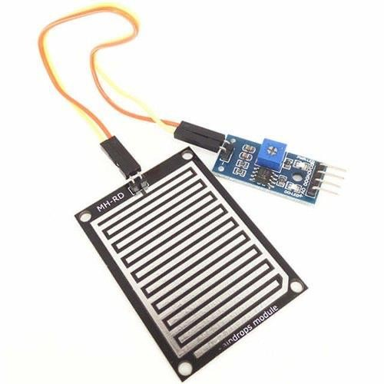

**FIGURE 3.3 RAIN SENSOR WITH LM393**

Rain sensors are used in the detection of water beyond what a humidity sensor can detect. It can be used as a switch when raindrop falls on the rain board and also for measuring rainfall intensity. The module features, a rain board and the control board that is separate for more convenience, power indicator LED and an adjustable sensitivity though a potentiometer.

The rain sensor **detects water that comes short circuiting the tape of the printed circuits**. The sensor acts as a variable resistance that will change status: the resistance increases when the sensor is wet and the resistance is lower when the sensor is dry.

Rain sensors are major components of the automatic systems used **in regions where rainfall is observed**

**during the months of irrigation**. These devices automatically turn off the irrigation system upon receiving a desired amount of rainfall and enable the system to resume its preset conditions when the device is dried.

## SERVO MOTOR:

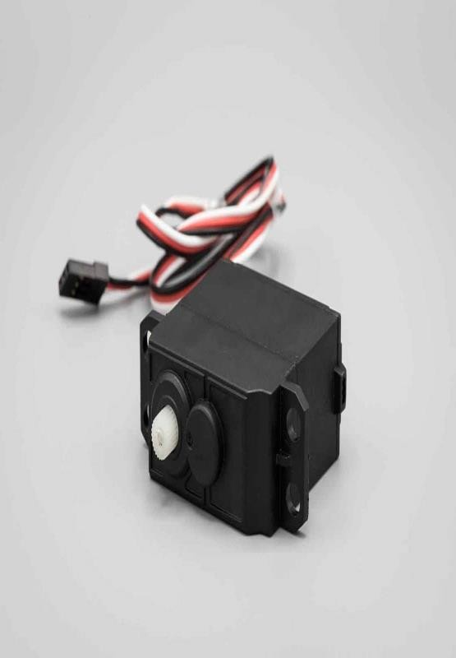

**FIGURE 3.4 SERVO MOTOR**

Micro Servo Motor SG90 is a tiny and lightweight server motor with high output power. Servo can rotate approximately 180 degrees (90 in each direction), and works just like the standard kinds but smaller. You can use any servo code, hardware or library to control these servos. Good for beginners who want to make stuff move without building a motor controller with feedback & gear box, especially since it will fit in small places. It comes with a 3 horns (arms) and hardware.

The TowerPro SG90 mini servo is lightweight, high-quality and lightning-fast. The servo is designed to work with almost all radio control systems. The SG90 mini servo with accessories is perfect for R/C helicopter, plane, car, boat and truck use.

It equips Carbon Fiber Gears which makes the servo motor much lighter than the same metal gear motor. For small load applications using the metal gear, servo motor adds on unnecessary weight, so we suggest using these lightweight plastic gear servo motors.The TowerPro SG90 9g Mini Servo is a 180° rotation servo. It is a Digital Servo Motor that receives and processes PWM signal faster and better. It equips sophisticated internal circuitry that provides good torque, holding power, and faster updates in response to external forces.

SAMPLE SOURCE CODE

#include<Servo.h> int lightval;

int lightpin=A0; int tm=100;

int servopin=3; Servo myservo; int angle;

void setup() { Serial.begin(9600); pinMode(lightpin,INPUT); myservo.attach(servopin); pinMode(servopin,OUTPUT);

}

void loop() { lightval=analogRead(lightpin); Serial.println(lightval); delay(tm);

angle= lightval/5; myservo.write(angle); Serial.println("anlge is"); Serial.println(angle);

}

### RIET| Department of ECE 12

1. **LED**:

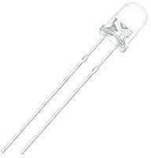

**FIGURE 3.5.1 LED**

A **light-emitting diode** (**LED**) is a [semiconductor](https://en.wikipedia.org/wiki/Semiconductor) [light source](https://en.wikipedia.org/wiki/Light_source) that emits light when [current](https://en.wikipedia.org/wiki/Electric_current) flows through it. [Electrons](https://en.wikipedia.org/wiki/Electron) in the semiconductor recombine with [electron holes,](https://en.wikipedia.org/wiki/Electron_hole) releasing energy in the form of [photons.](https://en.wikipedia.org/wiki/Photon) The colour of the light (corresponding to the energy of the photons) is determined by the energy required for electrons to cross the [band gap](https://en.wikipedia.org/wiki/Band_gap) of the semiconductor. White light is obtained by using multiple semiconductors or a layer of light-emitting [phosphor](https://en.wikipedia.org/wiki/Phosphor) on the semiconductor device.

Appearing as practical electronic components in 1962, the earliest LEDs emitted low- intensity [infrared](https://en.wikipedia.org/wiki/Infrared) (IR) light .Infrared LEDs are used in [remote-control](https://en.wikipedia.org/wiki/Remote-control) circuits, such as those used with a wide variety of consumer electronics. The first visible-light LEDs were of low intensity and limited to red. Early LEDs were often used as indicator lamps, replacing small [incandescent bulbs,](https://en.wikipedia.org/wiki/Incandescent_light_bulb) and in [seven-segment displays.](https://en.wikipedia.org/wiki/Seven-segment_display) Recent developments have produced LEDs available in [visible,](https://en.wikipedia.org/wiki/Visible_spectrum) [ultraviolet](https://en.wikipedia.org/wiki/Ultraviolet) (UV), and infrared wavelengths, with high, low, or intermediate light output, for instance white LEDs suitable for room and outdoor area lighting. LEDs have also given rise to new types of displays and sensors, while their high switching rates are useful in advanced communications technology with applications as diverse as [aviation lighting,](https://en.wikipedia.org/wiki/Navigation_light#Aviation_navigation_lights) [fairy](https://en.wikipedia.org/wiki/Fairy_lights) [lights](https://en.wikipedia.org/wiki/Fairy_lights), [automotive headlamps,](https://en.wikipedia.org/wiki/Automotive_lighting#Light-emitting_diodes_(LED)) advertising, [general lighting,](https://en.wikipedia.org/wiki/Lighting) [traffic signals,](https://en.wikipedia.org/wiki/Traffic_signal) camera flashes, [lighted](https://en.wikipedia.org/wiki/LED_wallpaper) [wallpaper,](https://en.wikipedia.org/wiki/LED_wallpaper) [horticultural grow lights](https://en.wikipedia.org/wiki/Grow_light), and medical devices.

LEDs have many advantages over incandescent light sources, including lower power consumption, longer lifetime, improved physical robustness, smaller size, and faster switching. In exchange for these generally favorable attributes, disadvantages of LEDs include electrical limitations to low voltage and generally to DC (not AC) power, inability to provide steady illumination from a pulsing DC or an AC electrical supply source, and lesser maximum operating temperature and storage

temperature. In contrast to LEDs, incandescent lamps can be made to intrinsically run at virtually any supply voltage, can utilize either AC or DC current interchangeably, and will provide steady illumination when powered by AC or pulsing DC even at a frequency as low as 50 Hz. LEDs usually need electronic support components to function, while an incandescent bulb can and usually does operate directly from an unregulated DC or AC power source.

Even though white light can be created using individual red, green and blue LEDs, this results in poor colour rendering, since only three narrow bands of wavelengths of light are being emitted. The attainment of high efficiency blue LEDs was quickly followed by the development of the first [white](https://en.wikipedia.org/wiki/Light-emitting_diode#Phosphor-based_LEDs) [LED.](https://en.wikipedia.org/wiki/Light-emitting_diode#Phosphor-based_LEDs) In this device a Y3Al5O 12Ce (known as "[YAG](https://en.wikipedia.org/wiki/YAG)" or Ce:YAG phosphor) [cerium](https://en.wikipedia.org/wiki/Cerium)-doped phosphor coating produces yellow light through [fluorescence.](https://en.wikipedia.org/wiki/Fluorescence) The combination of that yellow with remaining blue light appears white to the eye. Using different [phosphors](https://en.wikipedia.org/wiki/Phosphor) produces green and red light through fluorescence. The resulting mixture of red, green and blue is perceived as white light, with improved [colour](https://en.wikipedia.org/wiki/Color_rendering) [rendering](https://en.wikipedia.org/wiki/Color_rendering) compared to wavelengths from the blue LED/YAG phosphor combination.

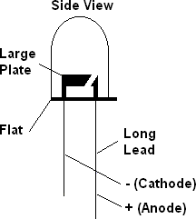

**FIGURE 3.5.2 LED STRUCTURE**

## SAMPLE SOURCE CODE

int sensorPin=A4; int sensorValue = 0; int led = 12;

#include<SoftwareSerial.h>

void setup() {

pinMode(led, OUTPUT); Serial.begin(9600);

}

void loop() {

Serial.println("Welcome to LDR tutorial"); sensorValue = analogRead(sensorPin); Serial.println(sensorValue);

if(sensorValue < 100)

{

Serial.println("LED light on"); digitalWrite(led,HIGH); delay(1000);

}

digitalWrite(led,LOW); delay(sensorValue);

}

**Circuit diagram:**

# CHAPTER 4 PROJECT

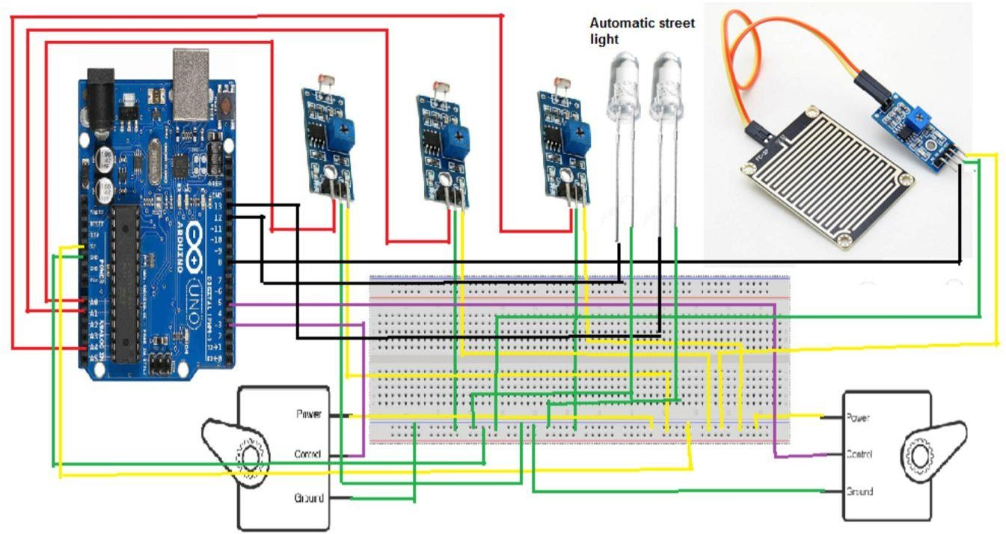

**FIGURE 4.1 CIRCUIT DIAGRAM**

# CHAPTER 5 SOFTWARE

## Arduino IDE:

The Arduino Integrated Development Environment - or Arduino Software (IDE) - contains a text editor for writing code, a message area, a text console, a toolbar with buttons for common functions and a series of menus. It connects to the Arduino hardware to upload programs and communicate with them.

Programs written using Arduino Software (IDE) are called **sketches**. These sketches are written in the text editor and are saved with the file extension .ino. The editor has features for cutting/pasting and for searching/replacing text. The message area gives feedback while saving and exporting and also displays errors. The console displays text output by the Arduino Software (IDE), including complete error messages and other information. The bottom righthand corner of the window displays the configured board and serial port. The toolbar buttons allow you to verify and upload programs, create, open, and save sketches, and open the serial monitor

### download (4).jpg.

**FIGURE 5.1 ARDUINO IDE**

## COMPLETE CODE:

#include<Servo.h> int lightval;

int buttonState = 0; int lightval1;

int ldr0=A0; int ldr01=A1; int tm=100;

int servopin=3; int servopin1=5; Servo myservo; Servo myservo1; int angle;

const int ledPin = 12; const int ldrPin = A4; void setup() { Serial.begin(9600); pinMode(ldr0,INPUT); pinMode(ldr01,INPUT);

myservo.attach(servopin); myservo1.attach(servopin1); pinMode(servopin,OUTPUT); pinMode(servopin1,OUTPUT); pinMode(8, INPUT); pinMode(13, OUTPUT); pinMode(ledPin, OUTPUT); pinMode(ldrPin, INPUT);

}

void loop() { lightval=digitalRead(ldr0); Serial.print("lightval : ");

Serial.println(lightval); delay(tm);

// if (lightval==0)

if (lightval==0 && lightval1==1)

{

myservo.write(0); //delay(1000); Serial.println("servo0 0 degree");

myservo1.write(0); //delay(1000); Serial.println("servo1 0 degree");

//angle= lightval/5;

// myservo.write(angle);

//Serial.println("anlge is");

//Serial.println(angle);

}

lightval1=digitalRead(ldr01); Serial.print("lightval1 : "); Serial.println(lightval1); delay(tm);

//if (lightval1==0)

// if (lightval1==0 && lightval1==1) if (lightval==1 && lightval1==0)

{

myservo.write(180); //delay(1000); Serial.println("servo0 180 degree"); myservo1.write(180); //delay(1000); Serial.println("servo1 180 degree");

}

if (lightval==0 && lightval1==0)

{

myservo.write(90); //delay(1000); Serial.println("servo0 180 degree");

myservo1.write(90); //delay(1000); Serial.println("servo1 180 degree");

}

buttonState = digitalRead(8); if (buttonState == LOW) { Serial.print(buttonState); digitalWrite(13, HIGH);

myservo.write(0); //delay(1000); Serial.println("servo0 180 degree"); myservo1.write(180); //delay(1000); Serial.println("servo1 180 degree");

} else

{

digitalWrite(13, LOW);

}

int ldrStatus = analogRead(ldrPin); if (ldrStatus >=300) { digitalWrite(ledPin, HIGH); Serial.print(ldrStatus);//

Serial.println("----LDR HIGH DARK TIME, LED is ON");

}

else { Serial.print(ldrStatus);

Serial.println("----LDR LOW DAY TIME, LED is OFF");

digitalWrite(ledPin, LOW); delay(1000);

}

}

# CHAPTER 6 EXPERIMENTAL RESULTS

1. **Automatic light:**

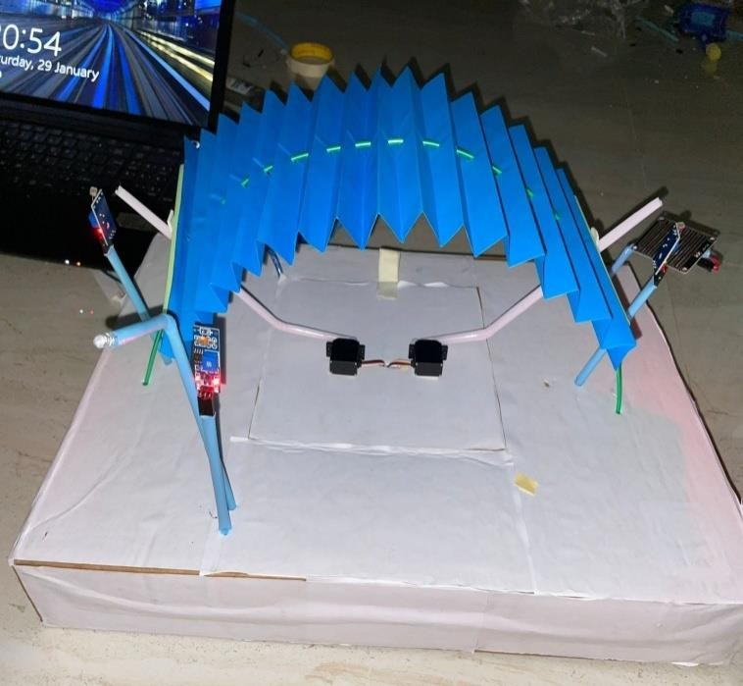

# FIGURE 6.1.1 DURING DAY

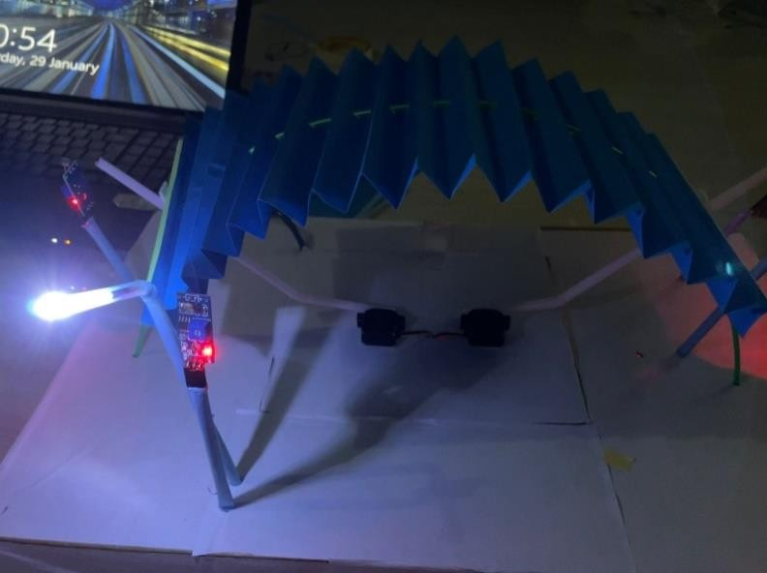

**FIGURE 6.1.2 DURING NIGHT**

# AUTOMATIC SUN SHADE:

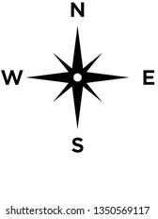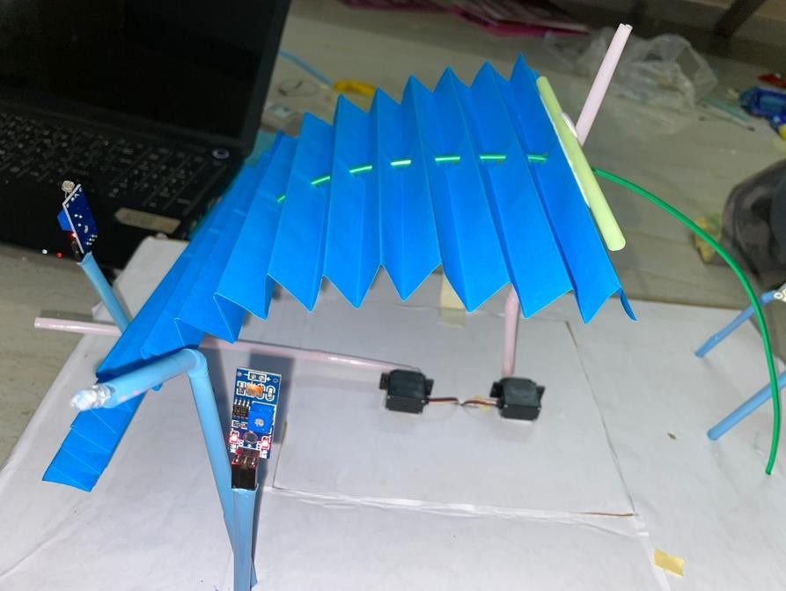

**FIGURE 6.2.1 WHEN THE SUN IS IN EAST**

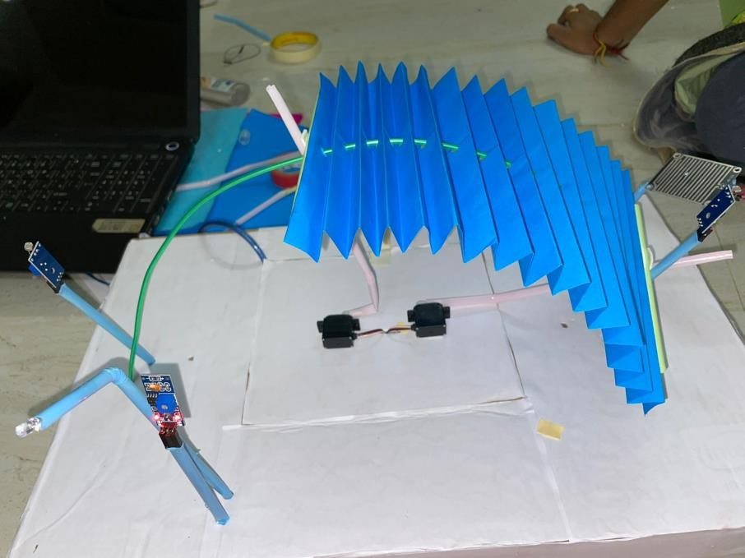

# FIGURE 6.2.2 WHEN THE SUN IS IN WEST

1. **EXPANSION DURING RAIN:**

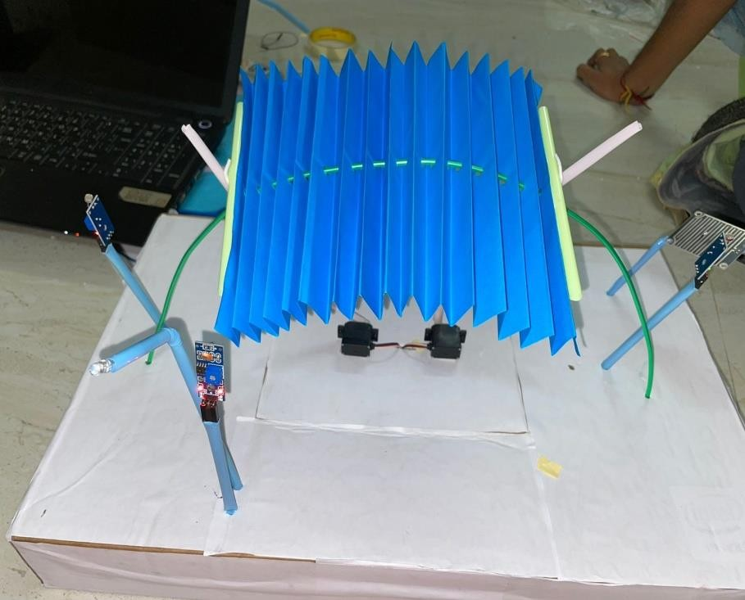

# FIGURE 6.3.1 DURING NO RAIN

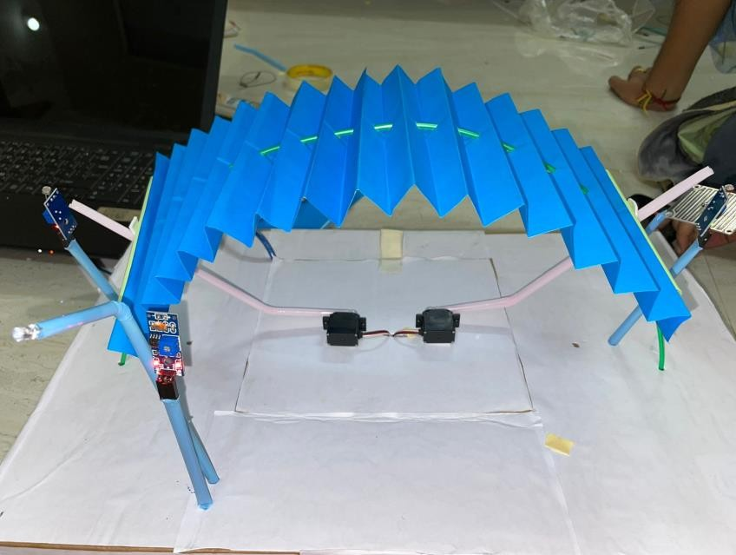

**FIGURE 6.3.2 DURING RAIN**

# CHAPTER 7 ADVANTAGES

* + The architectural model of a bus stop is easy to construct.
  + It provides shelter during peak hours, and also during rainy day the roof expand so the it provides shelter for more number of people.
  + It was echo friendly and also provides shelter based on nature conditions.
  + The automatic lights and installed so it provides the safety measure and also people can use public transport during nights without any problem.

# CHAPTER 8 FUTURE SCOPE

* + May be in future we can install solar panel and generate the energy which is used for the movement of roof
  + And also the solar energy is stored and used during night for the street lights.
  + We can also install an IOT based GSM module connect to LCD which displays the position of the respective buses.
  + We can install a security alarm in case the passengers had any problem they can easily report.

# CONCLUSION

* In this updated generation everything was changing to make human life more comfortable. But still we are using the normal bus stops which provide only half shelter when the sun is bright and the light has to be ON by the people ,so avoid such problems and make it more comfortable we are constructed the architectural model of a bus stop with automatic sunshade. Here the roof moves based on the sun position and also during rainy day it expand to provide shelter for more people.
* The automatic street lights are used so during night the bus stop will not be dark anymore.
* We used architectural model which attracts the modern society. It makes the travelling comfort so people use public transport which avoid pollution.

# REFERENCES

* Architectural model of a bus stop with automatic sun shade by project hub in both 1st version & 2nd version.
* https://en.wikipedia.org/wiki/Arduino_IDE
* [https://create.arduino.cc/projecthub/addicttux/architectural-model-of-a-bus-stop-with-](https://create.arduino.cc/projecthub/addicttux/architectural-model-of-a-bus-stop-with-automatic-sunshade-1647a3) [automatic-sunshade-1647a3](https://create.arduino.cc/projecthub/addicttux/architectural-model-of-a-bus-stop-with-automatic-sunshade-1647a3)
* [https://create.arduino.cc/projecthub/addicttux/architectural-model-of-a-bus-stop-with-](https://create.arduino.cc/projecthub/addicttux/architectural-model-of-a-bus-stop-with-automatic-sunshade-v2-b7cb28) [automatic-sunshade-v2-b7cb28](https://create.arduino.cc/projecthub/addicttux/architectural-model-of-a-bus-stop-with-automatic-sunshade-v2-b7cb28)
* https://www.arduino.cc/en/pmwiki.php?n=Main/arduinoBoardUno
* <http://www.jselectronics.com.my/index.php?ws=showproducts&products_id=1963634>
* https://thinkrobotics.in/products/rain-detection-sensor-with-lm393-comparator